HW STOCK DATA SCREENSHOTS

(2014 – 2016 )

**TAB 2014**

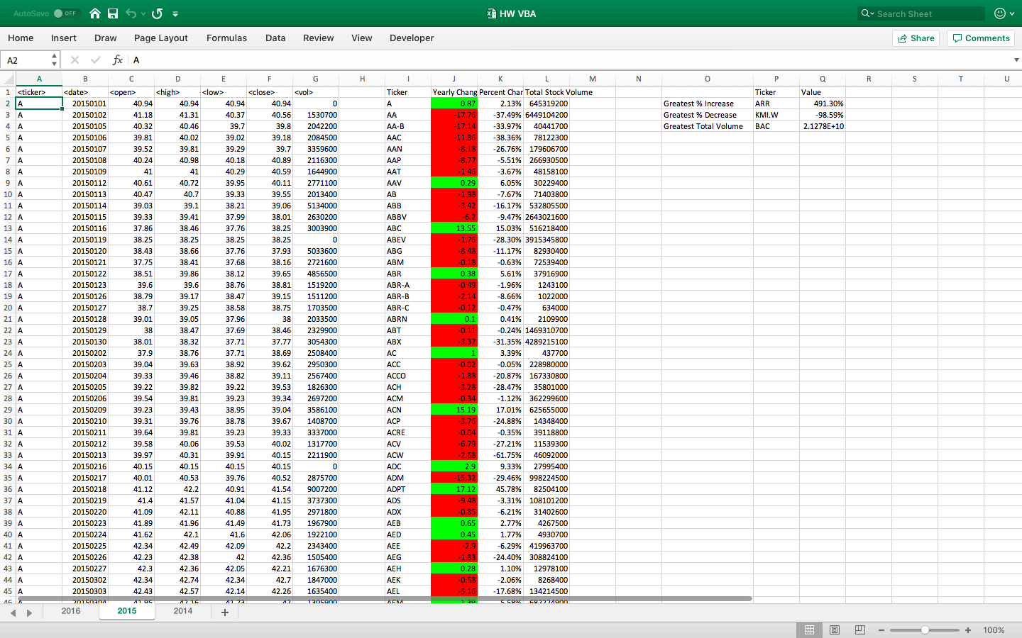

**TAB 2015**

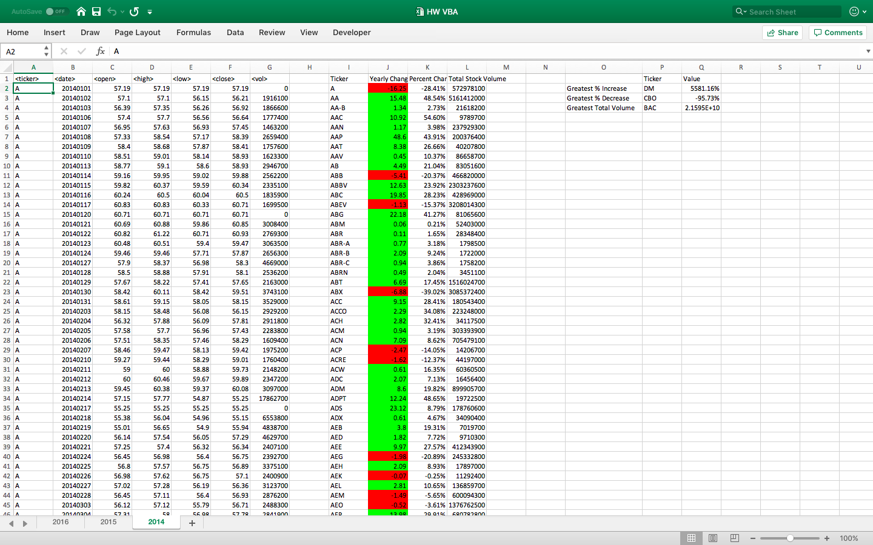

**TAB 2016**

